The Preamble to the U.S. Constitution
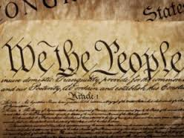

We the People of the United States, in Order to form a more perfect Union, establish Justice, insure domestic Tranquility, provide for the common defense, promote the general Welfare, and secure the Blessings of Liberty to ourselves and our Posterity, do ordain and establish this Constitution for the United States of America.

- “To Form a More Perfect Union” is the first goal of the Constitution. Why do you think this goal comes first?

- The Preamble’s second goal is to “Establish Justice.” What could it mean to “establish” justice?

- The third goal is “To Insure Domestic Tranquility.” What does it mean to “insure domestic tranquility”?

- The remaining three goals are to “provide for the Common Defense, promote the general welfare, and secure the blessings of Liberty to ourselves and our Posterity. What does this mean?

