MODEL GOVERNMENT TEST
STUDY GUIDE

- Legislative Vocabulary
  - Be able to define 15 terms

- How a Bill Becomes a Law
  - Know the song
  - Know the chart

- What was the roll of the journalists and lobbyists in the legislative process?

- What are the checks and balances between the Executive and Legislative Branch federal government?

Test Date:

How a Bill becomes a Law

Describe the process of how a bill becomes a law.
For each step identify:
- Who is involved
- Where does it take place
- What happens during this step
- Think: about amendments, voting, research, discussion, reading of the bill

Label each step clearly.

Step 1: A bill begins as an idea

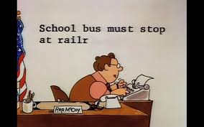 Step 2: Ideas for bills are proposed to Congressmen by:
- Constituents
- President
- Congressman
Congressman writes a draft of the bill

Step 3: The bill goes to a House of Representatives’ committee
- Researched
- Debated
- Experts and lobbyists can testify on the bill
- Voted on – Leaves committee or DIES!!!

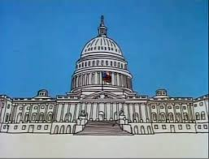 Step 4: The bill goes to the House of Representatives
- Read and introduced on the floor of the House of Representatives
- Debated
- Amended
- Voted on – Passes or DIES!!!

Step 5: Senate Committee
- Same steps as House Committee

Step 6: The Senate
- Same steps as in House
- Voted on – Pass or DIE!!!!

Step 7: Becomes a law if the president signs the bill or it is vetoed by the President.

Images courtesy of © Schoolhouse Rock

