Name_______________________________________________
Book, Head, Heart

When you read, think about what is...
In the BOOK:  -What ‘s the story about?  -Who is telling the story?  -What has happened?  (Facts & Information)  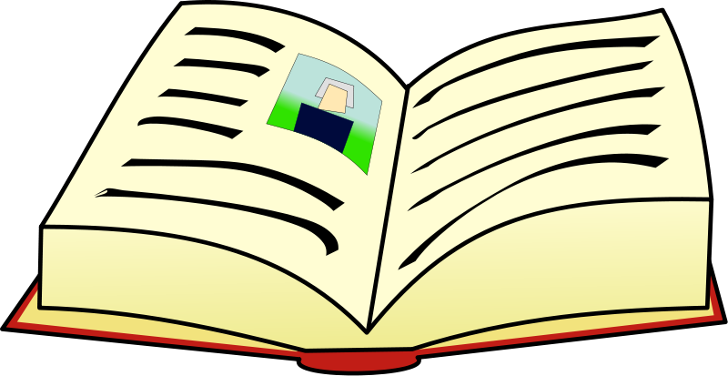 | Include page # for reference
In your HEAD:  -What surprised me?  -What confused me? Vocabulary?  -What challenged, changed, or confirmed my thinking?  -What did I notice? Signposts?  -I thought…  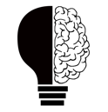 | Include quote/ page # for reference
In your HEART:  -What strikes a chord with you?  -How does this text impact you?  - What did I learn about myself?  - How will this help me be a better person?  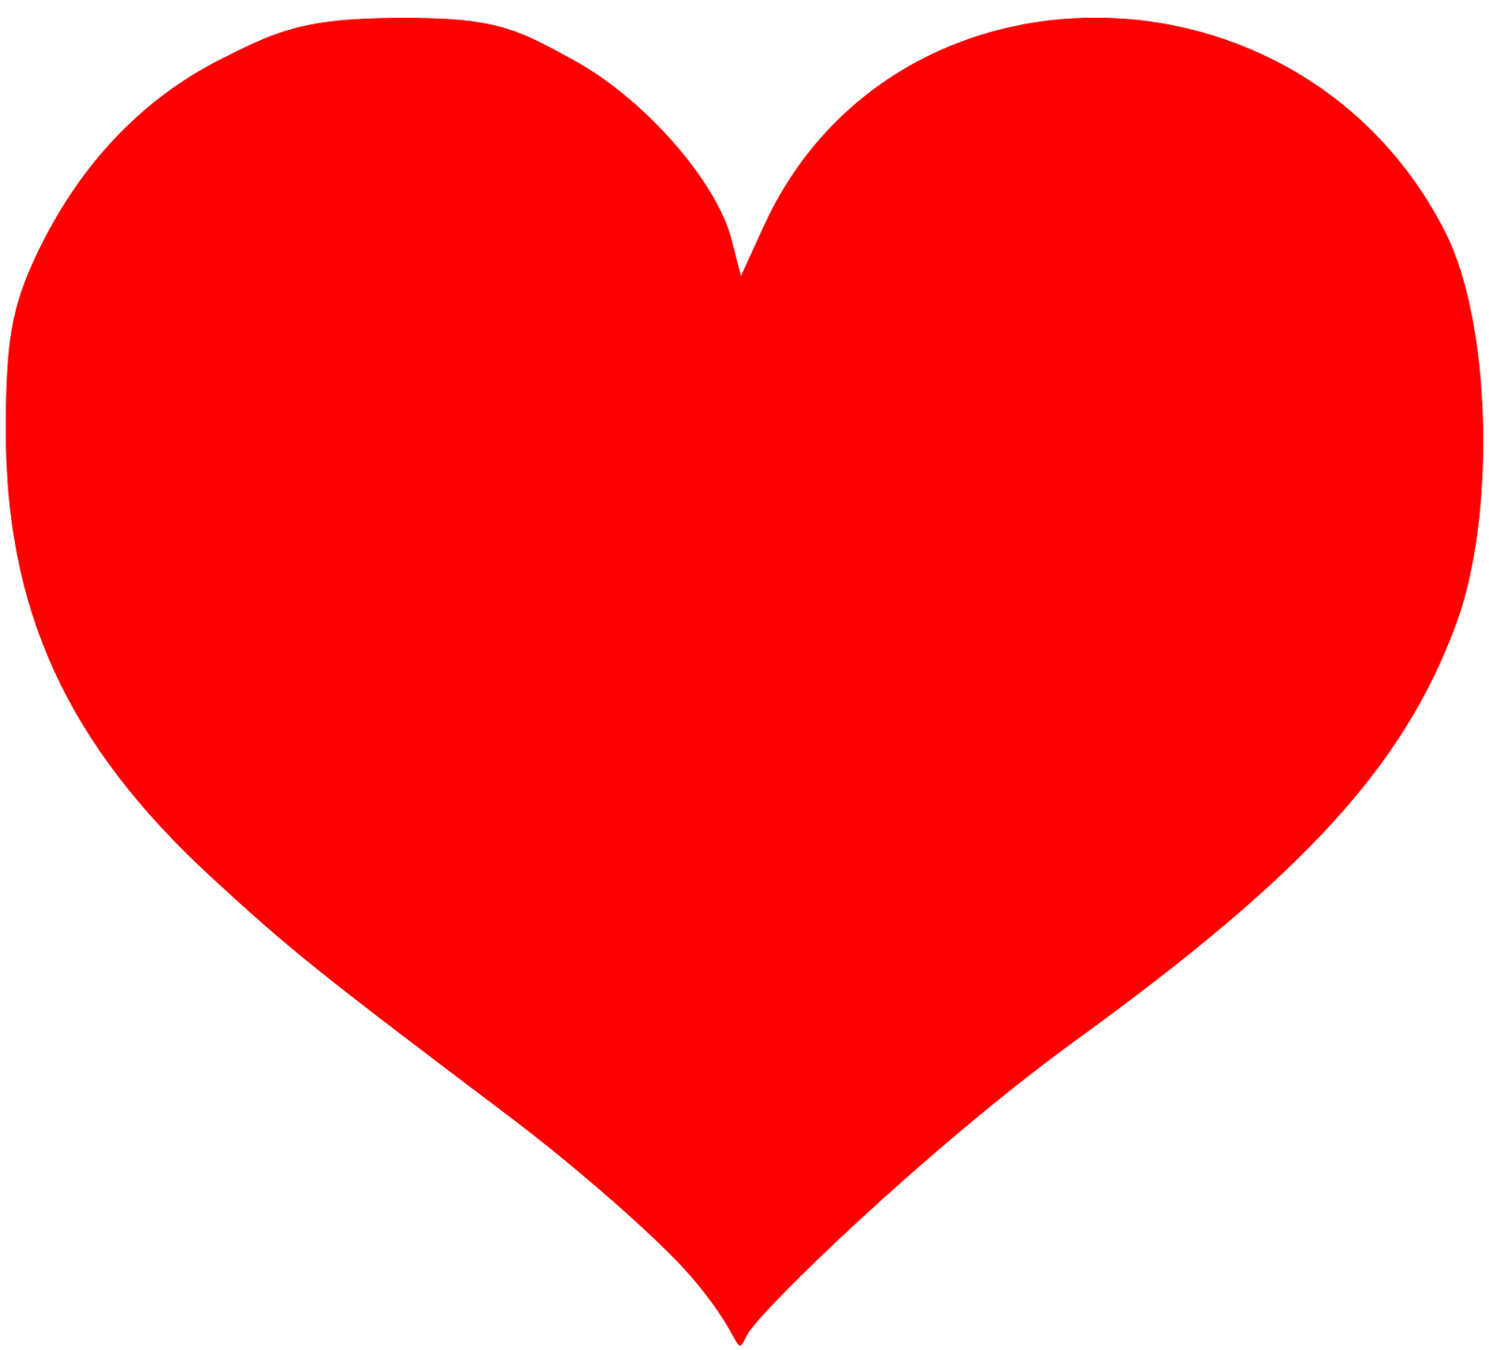 | Include quote/page # for reference

